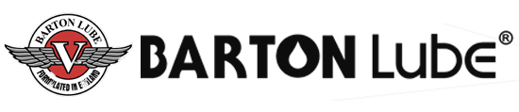
BARTON
LUBE

BARTON HEAT

Excelquench L602Z

quenchant Product code: Q022

Product Description:

Excelquench L602Z is a specially formulated, highly refined paraffinic accelerated quench oil.

When a piece of steel, containing sufficient carbon, is cooled rapidly it becomes considerably harder than it would if allowed to cool slowly. The preferred quenchant is one which removes heat slowly in the vapour stage and rapidly in the vapour transport stage. The quenchant must also remove heat slowly in the liquid cooling stage when the metal is completely wetted by the fluid in order to reduce distortion.

Excelquench L602Z part accelerated quench oil has been formulated to promote uniformed rates of cooling. It does not readily oxidise and has a naturally high flash point. Excelquench L602Z contains wetting agents and accelerator additives to help reduce the vapour blanket phase thus promoting faster quenching speeds.

Application:

Excelquench L602Z is recommended for use as an accelerated quench oil where consistent results are required on low alloy steels. Typical applications include high speed steel tools, ball bearings EN31, nuts and bolts EN5 and EN8 and components after carbo-nitriding EN1a, EN32.

Typical Test Data:

Excelquench | L602Z
Product code | Q022
Specific Gravity @ 15.6°C | 0.874
Kinematic Viscosity @ 40°C (cSt) | 21.9
Flash Point (°C) | 197
Pour Point (°C) | -15
Appearance | Clear amber fluid

Health & Safety:

Please refer to the safety data sheet, a copy of which is freely available to all of our customers.

